



Software Requirements Specification

Ecommerce Store



**Project By:**

Azhar Hayat (2021-CS-537)

Ali Hassan (2021-CS-521)

Musanif Ali (2021-CS-550)

University of Engineering and technology, LAHORE (Narowal Campus)

Department of Computer Science and Engineering

**Submitted To:**

Dr Yaseen ul Haq

Software Requirements Specification

for

Ecommerce Store

Version 1.0 approved

Prepared by Azhar Hayat(2021-CS-537)

November 14, 2023

Table of Contents

Table of Contents ii

Revision History ii

1. Introduction 1

1.1 Purpose 1

1.2 Document Conventions 2

1.3 Intended Audience and Reading Suggestions 2

1.4 Product Scope 3

1.5 References 31 Overall Description 4

2.1 Product Perspective 4

2.2 Functional Requirements 4

2.3 Operating Environment 17

2.4 Design and Implementation Constraints 17

2.5 Assumptions and Dependencies 18

2.6 System Architecture……………………….…………………...…………………………………19

2. External Interface Requirements 19

3.1 User Interfaces 19

3.3 Software Interfaces 20

3. System Features 24

4.1 User Authentication 24

4.2 Manage Products 24

4.3 Manage orders 25

4.4 Manage Customers 26

4. Other Nonfunctional Requirements 27

5.1 Performance Requirements 27

5.3 Security Requirements 28

5.4 Software Quality Attributes 28

5. Testing 29

Appendix A: Glossary 32

Revision History

|  |  |  |  |
| --- | --- | --- | --- |
| **Name** | **Date** | **Reason For Changes** | **Version** |
|  |  |  |  |
|  |  |  |  |

# Introduction

## Purpose

In the contemporary landscape of the digital age, our platform emerges as a powerful vehicle designed to navigate and thrive within the expansive global marketplace. Whether you're a local entrepreneur with aspirations for growth, a seasoned enterprise seeking to enhance your digital presence, or someone already engaged in sales through alternative platforms or social media, our comprehensive suite of tools and robust infrastructure is tailored to propel you towards success.

At the heart of our vision is an innovative e-commerce platform poised to revolutionize online marketplaces. Our goal is to craft a dynamic and vibrant space that goes beyond mere transactional exchanges. We envision a comprehensive ecosystem that not only facilitates seamless buying and selling but also fosters meaningful connections between buyers and sellers, creating a community-driven marketplace.

The foundation of our proposed e-commerce platform is built on the principles of accessibility, user-friendliness, and efficiency. We understand the importance of a positive user experience, and thus, our platform is meticulously designed to offer an intuitive and enjoyable shopping journey. Whether you're a tech-savvy consumer or a first-time online shopper, our user-friendly interface ensures that navigating through the marketplace is a breeze.

One of the key objectives of this project is to tap into the flourishing e-commerce market by providing a solution that addresses the evolving needs of both consumers and businesses. We recognize the transformative power of digital commerce and aim to be at the forefront of this revolution. Our platform serves as a catalyst for businesses, offering them the means to expand their reach, elevate their revenue streams, and ultimately achieve independence in the digital realm.

For consumers, our platform promises a seamless and convenient shopping experience, where they can explore a diverse range of products and services with ease. By connecting buyers and sellers in an efficient manner, we aim to create a marketplace that transcends geographical boundaries, enabling businesses to reach a broader audience and fostering a global community of commerce.

In essence, our proposed e-commerce platform is not just a transactional space but a transformative force in the digital marketplace. We invite you to join us on this exciting journey as we redefine the way commerce is conducted in the digital era, empowering businesses and consumers alike to thrive in the interconnected world of online trade.

## Document Conventions

1. **Document Identification**

Document Title: Software Requirements Specification (SRS) for E-commerce Store

Document Version: 1.0

Document Date: November 9, 2023

Authors: Azhar hayat (2021-CS-537)

Reviewers: Dr Yaseen Ul Haq

1. **Terminologies**

E-commerce: Electronic Commerce, the buying and selling of goods and services over the internet.

User: A person or entity using the e-commerce website.

Admin: A user with administrative privileges on the website.

Product Page: A web page displaying detailed information about a product.

Cart: A virtual shopping cart where users can add and manage selected items.

Payment Gateway: A third-party service used to process online payments.

SSL: Secure Sockets Layer, a standard security technology for establishing an encrypted link between a web server and a browser.

API: Application Programming Interface.

UI: User Interface.

UX: User Experience.

1. **Conventions**

Alignment: Justify

Heading: Bold, 16, Times New Roman

Sub Heading: Bold, 14, Times New Roman

General Heading: Bold, 12, Times New Roman

Body: Normal, 12, Times New Roman

## Intended Audience and Reading Suggestions

1. Audience

Developers: who will be responsible for building the e-commerce platform.

Designers: who need to understand design guidelines and wireframes.

Project managers: who will oversee the project timeline and resource allocation.

Quality assurance and tester: responsible for defining testing requirements and acceptance criteria.

1. Reading Suggestion

Developers: Focus on the "Functional Requirements" section for technical details and the "Database Schema" for data structure.

Designers: Explore the "User Interface Design" section for design guidelines, wireframes, and mockups.

Project Managers: Pay particular attention to the "Project Timeline" and "Resource Requirements" sections for project planning.

## Product Scope

In the ever-evolving landscape of commerce, investing in an E-commerce platform is not merely adopting a technological solution; it is a strategic leap into the future of your business. As we navigate the complexities of the digital age, the imperative to transcend regional boundaries and access the global marketplace becomes increasingly pivotal. Our E-commerce platform is not just a tool; it's a catalyst for your business's growth and global reach.

At its core, our platform is designed to simplify cross-regional commerce, making it accessible and efficient. By leveraging cutting-edge technology, we empower you to break free from geographical constraints and tap into markets worldwide. The platform serves as a gateway to new opportunities, allowing you to connect with a diverse and expansive customer base.

One standout feature is the elimination of the financial shackles associated with monthly charges. Our platform liberates you from the burden of exorbitant fees, offering a transparent and budget-friendly approach to expanding your business. This financial freedom is crucial for entrepreneurs and enterprises alike, allowing them to allocate resources where they matter most – in the enhancement of products and services.

The flexibility inherent in our platform extends beyond just financial considerations. You have the autonomy to choose hosting and domain plans tailored to your specific business needs. This not only ensures a seamless integration with your existing operations but also guarantees scalability without compromising affordability. Whether you're a startup with ambitious plans or an established business aiming to widen its global footprint, our platform grows with you.

Furthermore, our commitment to transparency extends to the user experience. We provide intuitive interfaces and robust analytics tools, giving you insights into customer behavior, market trends, and sales patterns. Armed with this information, you can make informed decisions to refine your strategies, optimize your offerings, and stay ahead of the competition.

In essence, our E-commerce platform is more than just a technological tool; it's a strategic partner in your business's journey toward global success. By embracing the possibilities of the digital era, you're not just adapting to change – you're leading the charge, defining the trajectory of your business in a world where connectivity and accessibility are paramount.

# Overall Description

## Product Perspective

In today's world with fancy technology, local businesses need to step up and think big. We can't stick to just our neighborhood – it's time to go global. To do that, we need a smart solution to break down borders and open up new opportunities.

Whether you're a small shop or a big company, everyone should get a chance to sell things globally. The new tech age says we need a platform where we can easily sell and manage our stuff all around the world. Our cool platform is like a bridge that connects local businesses to the huge global market. It's not just a tool; it's like a doorway to a bunch of new possibilities. We made it super easy for sellers of all sizes to handle the ins and outs of selling things internationally.

Now, every business, no matter how big or small, should have a way to reach the global market. Our platform is here to help businesses grow by making it easy to sell and manage products globally.

As technology keeps changing things, businesses need to get on board in the online world. The global market isn't just for big companies anymore – it's a place where all kinds of businesses can do well. With our platform, businesses not only keep up with the times but also get a chance to be part of the exciting future of selling things worldwide. It's like going from just around the corner to all around the world – a journey that sets businesses up for success in this new era of tech.

## Functional Requirement

Ecommerce is designed to provide users with a wide range of functions to create a seamless shopping experience. These functions can be categorized into the following groups:

* User Account Management

The proposed e-commerce platform boasts a comprehensive set of features to facilitate a seamless and engaging user experience. At the core of this digital marketplace is the User Account Management system, designed to enable users to create and personalize their accounts securely. This system not only handles login and logout functionalities but also provides options to ensures the protection of user data through encryption.

* Product Catalog

The Product Catalog serves as the virtual storefront, offering a visually appealing and well-organized display of products. Each item within the catalog is accompanied by detailed information, including images, descriptions, prices, and specifications. The catalog is intelligently structured with categories and subcategories, complemented by features like search functionality and filters, enhancing user navigation.

* Shopping cart and checkouts

A crucial aspect of the e-commerce platform is the Shopping Cart and Checkouts system, providing users with a virtual basket to manage their selected items. The Checkout process is a user-friendly series of steps, guiding users through the provision of shipping details, selection of payment methods, and confirmation of their purchase. Multiple payment options are supported to ensure a secure and smooth transaction process.

* Order tracking and history

To enhance the post-purchase experience, the platform incorporates Order Tracking and History features. Users can monitor the real-time status and location of their orders, and the Order History provides a comprehensive record of past purchases, streamlining reordering and referencing.

* Admin Dashboard

Empowering administrators, the Admin Dashboard serves as a centralized control panel offering real-time insights into various aspects of the e-commerce business. It provides tools for managing product listings, overseeing order fulfillment, and monitoring key metrics such as sales and user activities.

* Customer Management

Customer Management tools are integrated to empower administrators in handling user accounts, addressing inquiries, and resolving issues. The system allows access to customer profiles, facilitating effective customer service and support.

* Order management

Efficient Order Management is facilitated through dedicated tools, enabling administrators to process and fulfill orders with ease. This includes order verification, inventory management, and coordination with shipping and logistics partners. The system also handles order-related processes such as cancellations, modifications, and refunds.

* Store stats

Store Stats, another integral component, offer valuable insights into the platform's performance. Visual analytics present metrics such as sales trends, popular products, and user demographics, assisting administrators in making informed, data-driven decisions to optimize the overall performance and user experience of the e-commerce platform.

So, E-commerce is not just a website where you buy things; it's a whole toolkit of features that work together to make your online shopping experience awesome. Each tool has its job, and together, they create a seamless and enjoyable way to shop from the comfort of your own screen.

Here the class diagram will show the functions of the product:

**Class diagram**

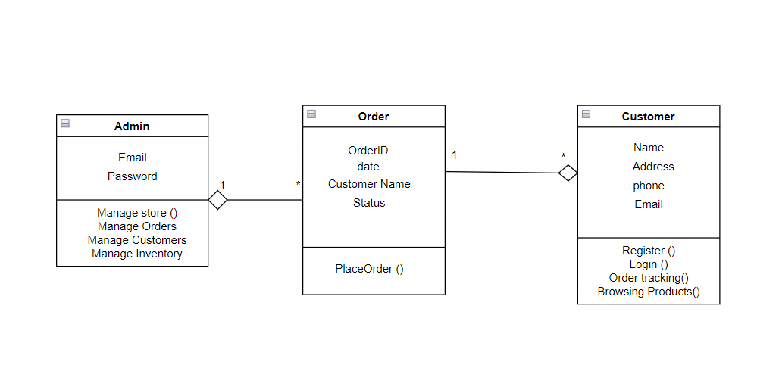

* **Use Case**

The use case diagram for E-commerce Store represents the primary actors and their interactions with the e-commerce system. It provides a visual overview of the system's functionalities and how different users interact with it.

Following the primary actor in the Ecommerce store.

* **Admin**
* **Customer**

While following are the use cases by these actors:

* User authentication
* Manage Products
* Manage Category
* Manage Orders
* Manage Customers
* Manage Store
* Manage Marketing
* Order processing
* Customer support
* Analytics and reporting
* Security Measurement
* Social Media Integration

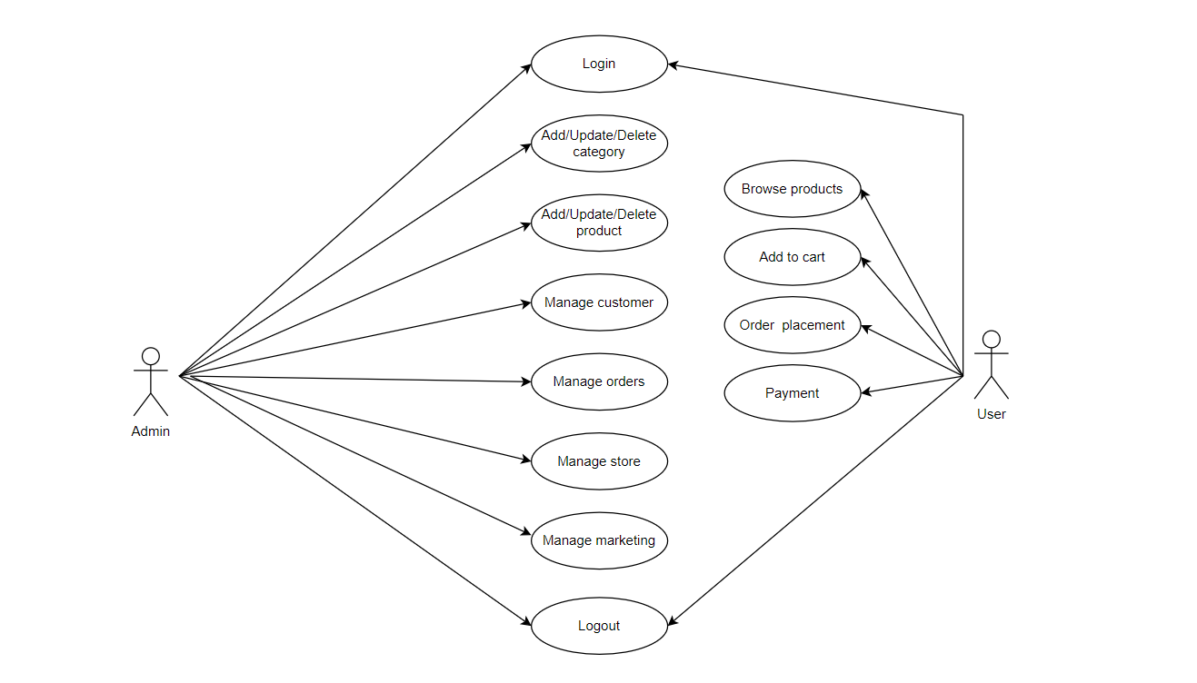The following diagram shows the details of the use case:

**Use case diagram**

* **Sequence Diagram (Customer Panel)**

Following (Sequence Diagram a) represents the sequence diagram for the customer screen in the Ecommerce store. The sequence diagram illustrates the dynamic interactions and sequence of events involved in the process of placing an order on E-commerce Store. This specific sequence represents how a customer interacts with the system to complete an order.

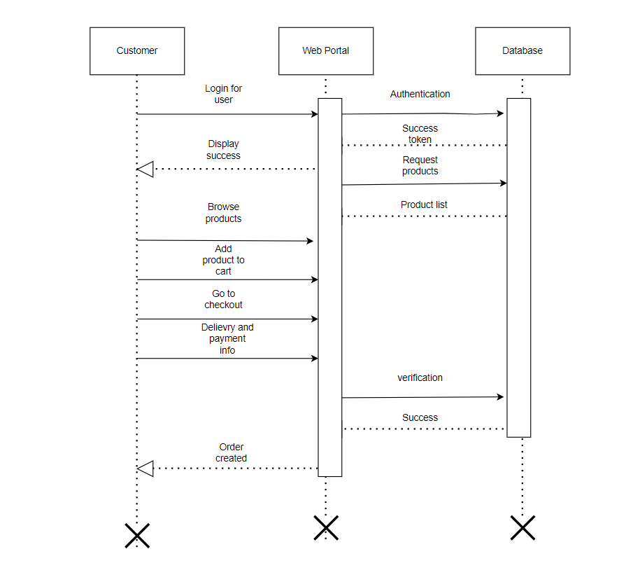

* **Sequence Diagram (Admin Panel)**

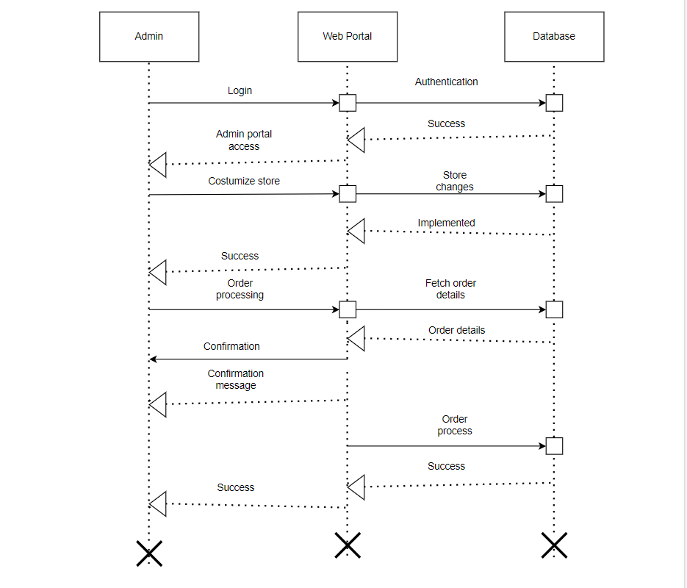A sequence diagram for an admin screen interaction in your e-commerce store's Software Requirements Specification (SRS) can help depict the sequence of interactions between an administrator and the system. The diagram (sequence Diagram b) represents the sequence diagram for the admin panel.

This sequence diagram provides a clear representation of the admin login process within the e-commerce system. It shows the steps involved, the interactions between the admin and the system, and the potential outcomes, ensuring a comprehensive understanding of this specific process.

* **Activity Diagram**

Creating an activity diagram for your e-commerce store in your Software Requirements Specification (SRS) can help provide a detailed view of the flow of activities and processes within a specific feature or use case. Following diagram represents the activity diagrams of the Ecommerce Store.

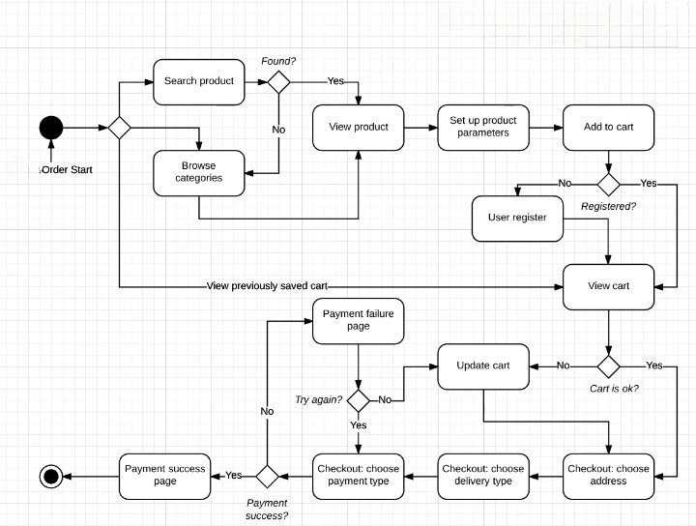

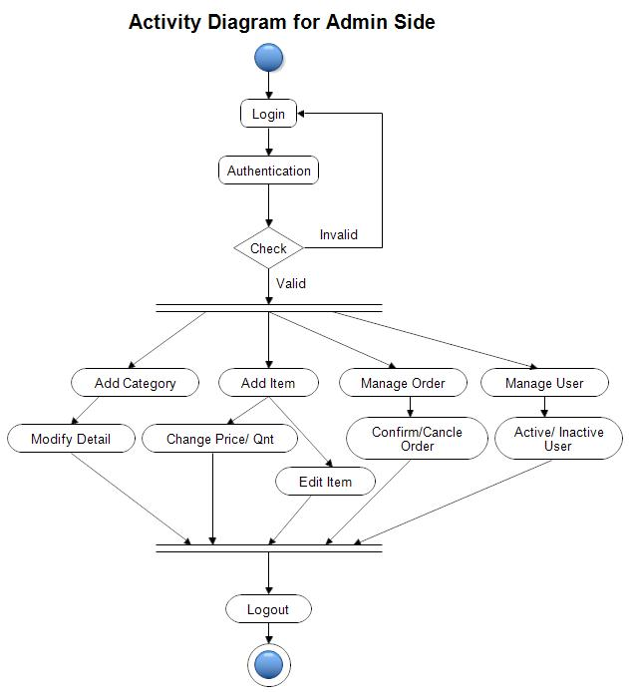

**Activity Diagram Admin**

* **State Diagram**

State diagrams model the various states that a system or component can exist in and the transitions between these states.

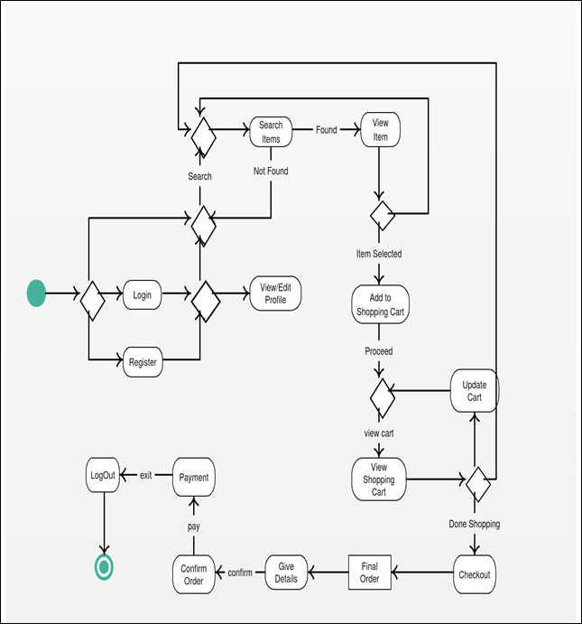

* **Component Diagram**

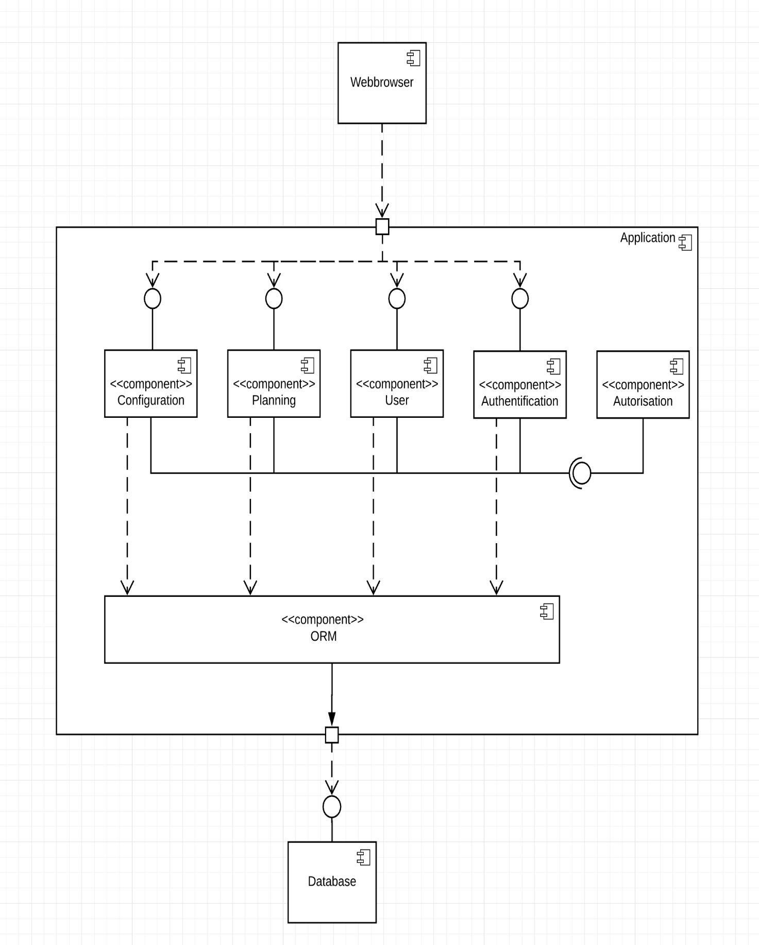

* **ER Diagram**

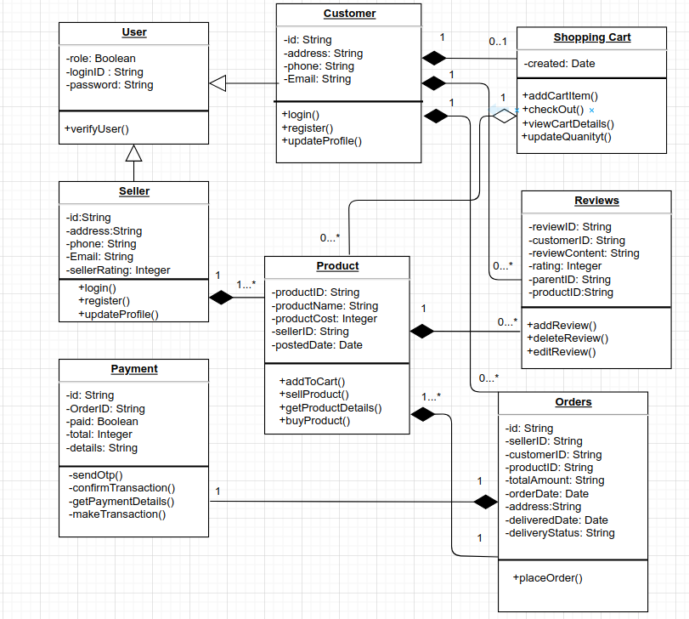

## Operating Environment

Ecommerce Store operates in a versatile software environment, compatible with a wide range of operating systems and versions. This includes support for common desktop and mobile platforms, such as Windows, Linux, macOS, iOS, and Android. The e-commerce platform is designed to seamlessly interact with various web browsers, ensuring accessibility to users across different devices. We maintain a commitment to staying current with the latest operating system versions to deliver a consistent and reliable user experience.

The flexible nature of the operating environment ensures that users can access and interact with Store from their preferred devices and operating systems, promoting accessibility and user satisfaction.

## Design and Implementation Constraints

1. **Interfaces and integrations**

Ecommerce Store interfaces with various applications and components, and it must coexist harmoniously with:

**Third-Party Applications:** Integration with payment gateways, shipping providers, and other third-party services.

**APIs:** Interacting with external APIs and services to enhance functionality.

1. **Technology Stacks and Databases**

**Front-end Technologies:** React, Tailwind CSS, Ant design

**Backend-end Technologies: Node JS, Express, Mongo DB**

1. **Parallel operations**

Certain operations in E-commerce Store must be capable of running in parallel to meet performance and scalability expectations. The system should effectively handle concurrent user interactions and transactions

1. **Security considerations**

Security is a paramount concern, and the software must address:

**Data Encryption:** Sensitive data must be encrypted using SSL for secure data transfer.

**Authentication and Authorization:** Robust user authentication and authorization mechanisms.

**Vulnerability Testing:** Regular security assessments to identify and mitigate potential vulnerabilities.

1. **Design conventions and standard**

The development team must follow specific design conventions and programming standards, which may include:

**Coding Standards:** Adherence to coding and naming conventions for consistency and maintainability.

**Design Patterns:** Utilization of industry-standard design patterns to ensure efficient and maintainable code.

## Assumptions and Dependencies

* **Assumptions**
* The coding should be error free.
* The system should be user friendly and easy to use for all its users.
* The system should provide the search query and quick support for the user requests.
* The system should be available 24/7.
* The system can be assessed from the any device that has interne connection.
* **Dependencies**
* The admin should have proper understanding of the products.
* The system should have general report store.
* The information of all the users must be store in the database which will be accessible by the product.

## System Architecture

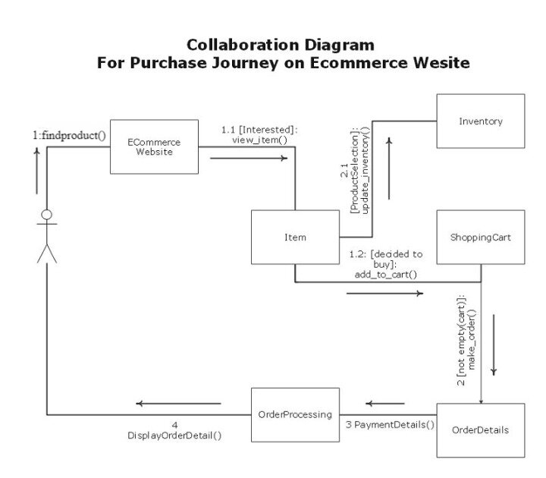The system architecture of an e-commerce platform typically involves a combination of front-end, back-end, and database components. Here's a high-level overview of a typical system architecture for an e-commerce platform:

**Collaboration diagram**

***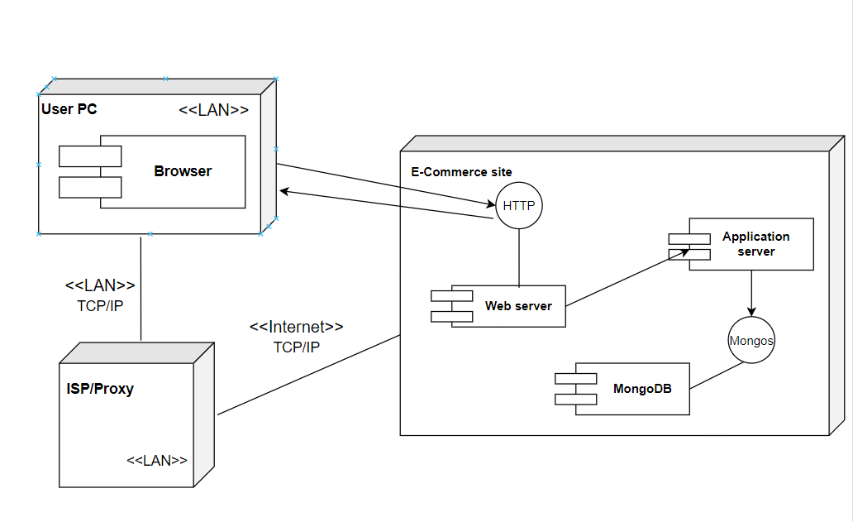*Deployment Diagram**

## Software Interfaces

The Software Interface feature focuses on providing a user-friendly and intuitive interface for administrators to interact with the e-commerce system. It includes functionalities such as navigation, layout, and visual design. This feature is of high priority as it directly affects the usability and user experience of the system. Here are the Screen of different software interfaces.

* 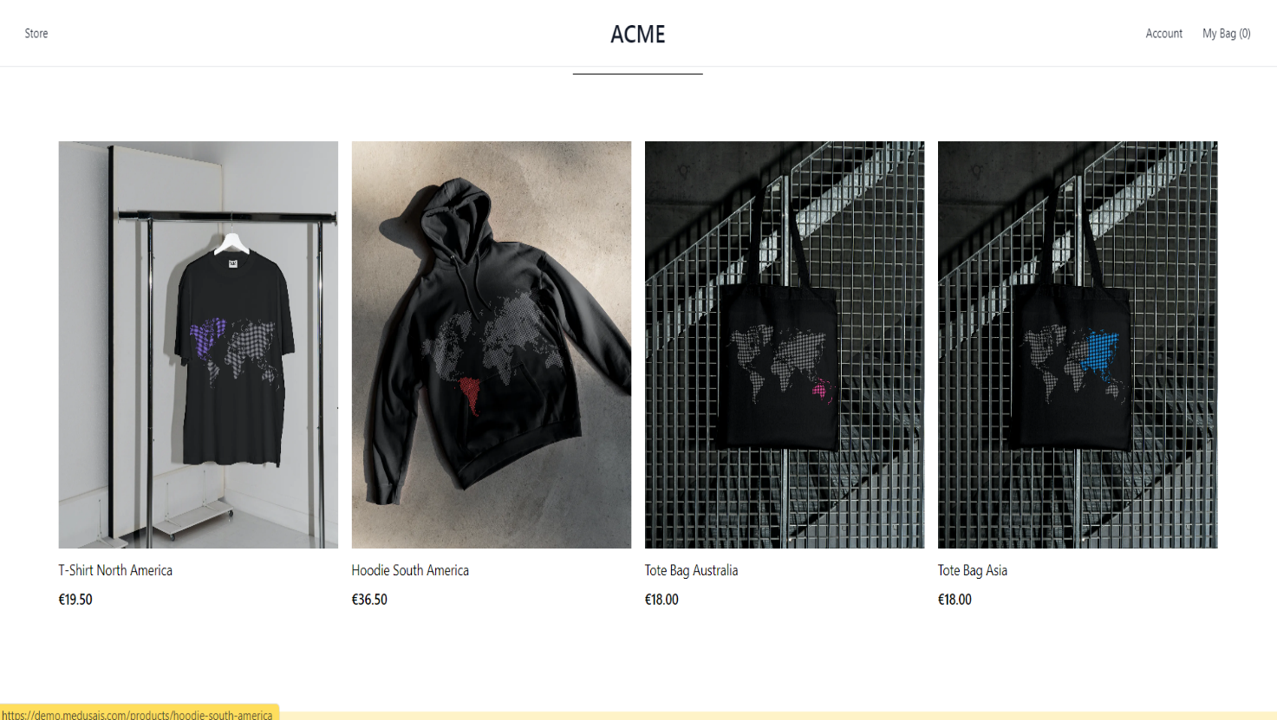**Store Front**
* 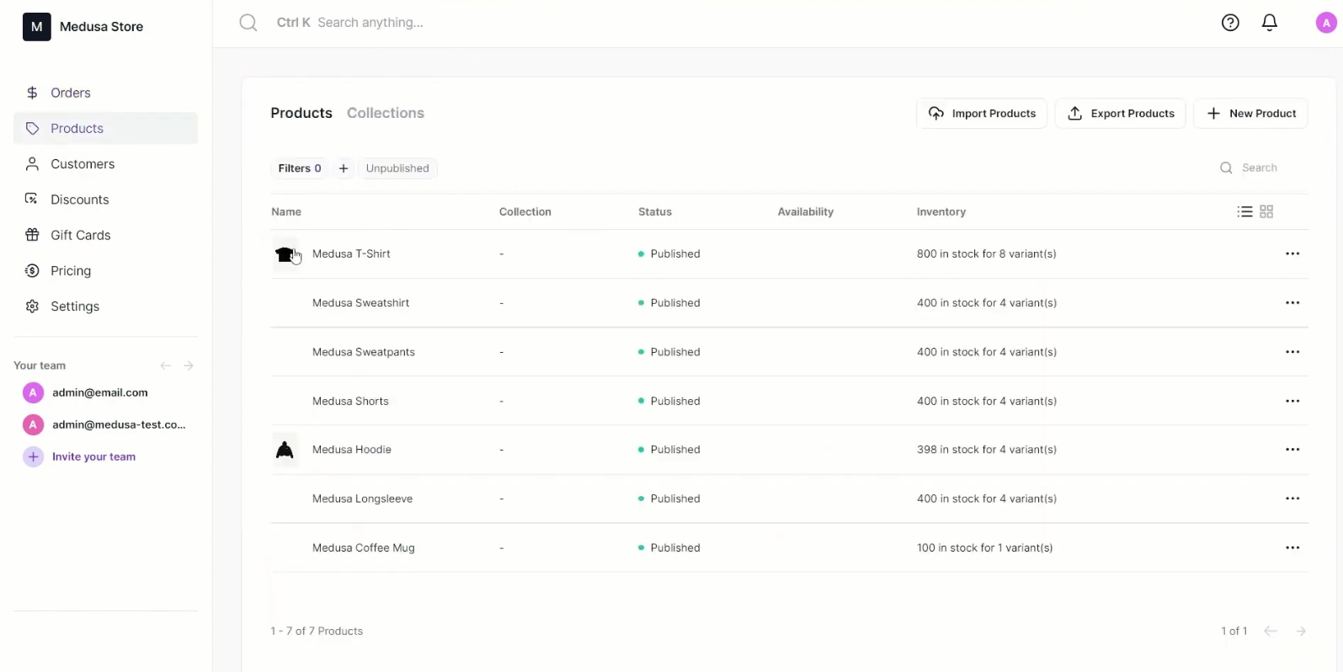 **Manage Products**
* **Manage Orders**

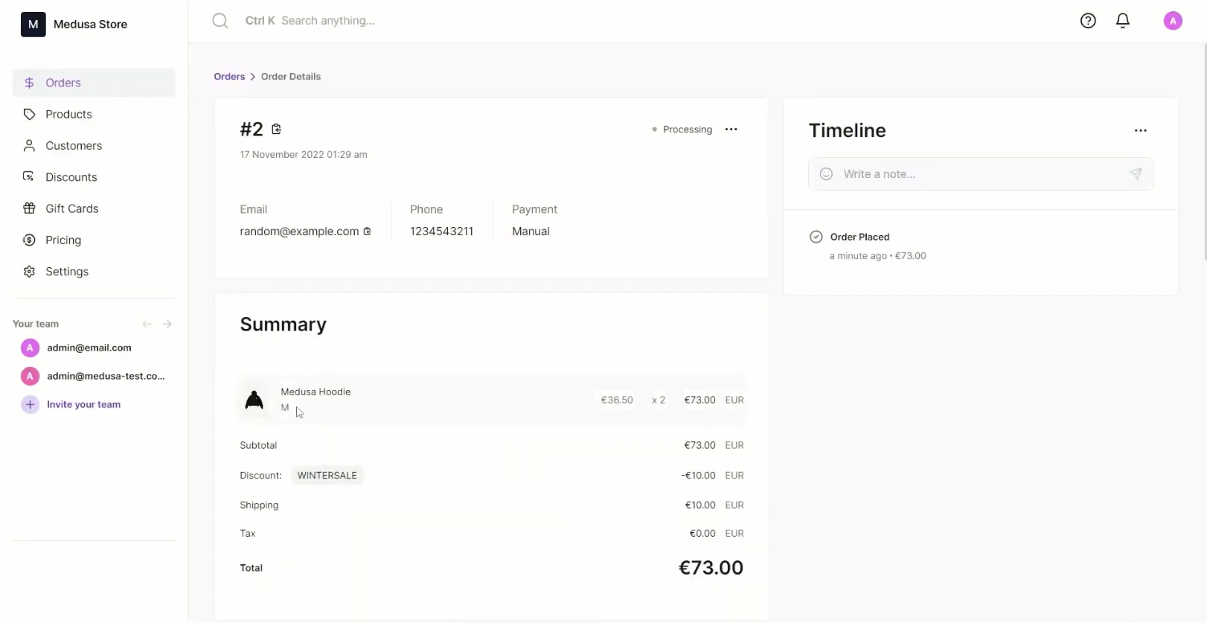

* 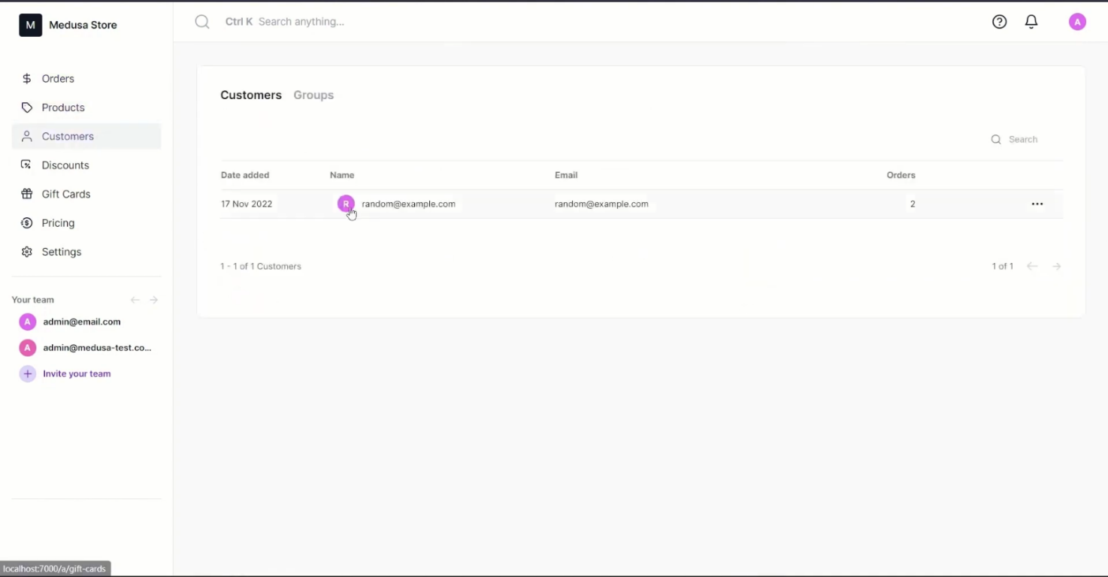**Manage Customers**
* **Folder Structure Client Side**

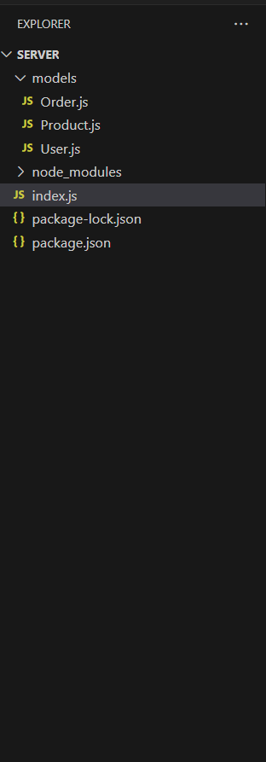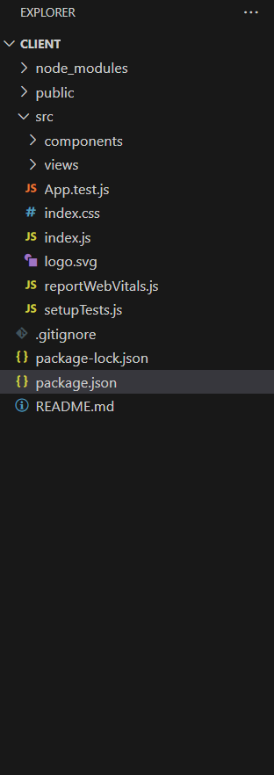

# System Features

## User Registration

**3.1.1 Description and Priority**

The User Registration feature allows users to create new accounts on the e-commerce website. It is of high priority as it is essential for users to register and access personalized features and functionalities.

**3.1.2 Response Sequences**

* User clicks on the "Sign Up" button on the website.
* System presents a registration form to the user.
* User enters their personal details, including name, email address, and password.
* User submits the registration form.
* System validates the provided information.
* If the information is valid, the system creates a new user account.
* System sends a confirmation email to the user.
* User receives the confirmation email and clicks on the confirmation link.
* System verifies the email confirmation and activates the user account.
* System displays a success message to the user, confirming their registration

**3.1.3 Functional Requirements**

* The system shall provide a user registration form with the fields like username, email and password.
* The system shall validate the user's input for the registration form.
* The system shall store the user's registration details securely.
* The system shall handle invalid inputs and display appropriate error messages to the user.

## Manage Products

**3.2.1 Description and Priority**

The Product Management feature enables administrators to manage the products available on the e-commerce website. It includes functionalities such as adding new products, updating existing product information, and removing products from the catalog. This feature is of high priority as it directly impacts the availability and accuracy of product information.

**3.2.2 Response Sequences**

* Administrator logs in to the admin dashboard.
* System presents a list of existing products.
* Administrator selects the "Add Product" option.
* System displays a form to enter product details, such as name, description, price, and image.
* Administrator fills in the product information and submits the form.
* System validates the provided information.
* If the information is valid, the system creates a new product entry in the database.
* System displays a success message and redirects the administrator to the product list.

**3.2.3 Functional Requirements**

* The system shall display a list of existing products in a user-friendly interface within the admin dashboard.
* The system shall provide an "Add Product" form with the fields like Name, Description, price, category, Inventory and variant.
* The system shall validate the entered product information
* The system shall handle invalid inputs and display appropriate error messages to the user.

## Manage Orders

**3.3.1 Description and Priority**

The Order Management feature enables administrators to manage customer orders on the e-commerce website. It includes functionalities such as viewing order details, updating order statuses, and generating order reports. This feature is of medium priority as it is crucial for efficient order processing and customer satisfaction

**3.3.2 Response Sequences**

* Administrator logs in to the admin dashboard.
* System presents a list of recent customer orders.
* Administrator selects an order from the list to view its details.
* System displays the order information, including customer details, itemized products, quantities, and total amount.
* Administrator reviews the order details and takes necessary actions, such as updating the order status or contacting the customer for clarification.
* System updates the order status in the database and notifies the customer if necessary.
* Administrator generates an order report for a specific time period or specific criteria, such as pending orders or completed orders.
* System generates the requested order report and presents it to the administrator for download or viewing.

## Manage Customers

**3.4.1 Description and Priority**

The Customer Management feature enables administrators to manage customer information on the e-commerce website. It includes functionalities such as viewing customer profiles, updating customer details, and managing customer support interactions. This feature is of medium priority as it contributes to effective customer service and personalized experiences.

**3.4.2 Response Sequences**

* Administrator logs in to the admin dashboard.
* System presents a list of registered customers.
* Administrator selects a customer from the list to view their profile.
* System displays the customer's profile information, including name, email, contact details, and order history.
* Administrator updates the customer's details, such as contact information or billing address.
* System validates the updated information and updates the customer's profile in the database.
* Administrator views the customer's order history to gain insights or provide support if needed.
* System displays the customer's order history, including order numbers, dates, and statuses.
* Administrator records customer support interactions or notes related to the customer's account.
* System saves the recorded interactions or notes in the customer's profile for future reference.

# Other Nonfunctional Requirements

## Performance Requirements

* **Response Time**

The website shall respond to user-initiated actions, such as page loading, search queries, and product filtering, within a maximum of 2 seconds under normal operating conditions.

* **Concurrent User Handling**

The website shall support a minimum of 500 concurrent users at any given time without significant degradation in performance.

* **Error Handling**

The website should handle errors gracefully and provide informative error messages to users within 5 seconds of encountering an error.

* **Scalability**

The platform should be designed to scale horizontally to accommodate a growing user base and increasing data volumes. It should seamlessly handle increased traffic, product listings, and user accounts without a substantial impact on performance.

* **Security**

Security measures must be implemented to safeguard user data, financial transactions, and sensitive information. The platform should comply with industry standards for encryption, secure sockets layer (SSL) protocols, and regularly undergo security audits to identify and address vulnerabilities.

* **Availability**

The e-commerce platform should aim for high availability, ensuring that it is accessible to users at all times. Scheduled maintenance and updates should be performed during low-traffic periods, and the platform should have failover mechanisms to minimize downtime.

* **Browser Compatibility**

The website should be compatible with major web browsers, ensuring a consistent and functional user experience across popular browsers like Chrome, Firefox, Safari, and Edge. This helps maximize the platform's accessibility to a diverse user base.

* **Performance Monitoring**

Continuous monitoring of the platform's performance is essential. This involves tracking key performance indicators (KPIs), system resource utilization, and response times. Performance monitoring tools should be implemented to detect and address any performance issues proactively.

* **Third Party Integration**

If the platform integrates with external services or APIs, compatibility and seamless communication should be ensured. The platform should gracefully handle situations where external services may experience downtime or changes in functionality.

## Security Requirements

Security requirements are essential to protect user data, ensure the integrity and confidentiality of information, and mitigate potential security risks associated with the e-commerce website.

* **User Authentication**

The website shall require users to authenticate their identities through secure and reliable methods (e.g., username and password, two-factor authentication) before accessing sensitive information or performing privileged actions.

* **Data Encryption**

The website shall use industry-standard encryption algorithms (e.g., AES, RSA) to encrypt sensitive data, such as user credentials, payment information, and personal details, during transmission and storage.

* **Access Control**

The website shall implement role-based access control (RBAC) mechanisms to enforce appropriate access privileges for different user roles (e.g., administrators, customers, employees), limiting access to authorized functionalities and data.

* **Secure Session Management**

The website shall employ secure session management techniques, such as session tokens, to ensure the integrity and confidentiality of user sessions, preventing session hijacking or tampering.

## Software Quality Attributes

* **Useability**

The website shall achieve a usability score of at least 80% in user testing evaluations based on established usability heuristics.

* **Reliability**

The website shall have a system uptime of at least 99.9% over any given month, minimizing service disruptions and downtime.

* **Maintainability**

The website's codebase shall adhere to coding standards and have a maintainability index of at least 80, as measured by static code analysis tools.

* **Performance Efficiency**

The website shall achieve a page load time of under 3 seconds for 90% of user requests, ensuring efficient and responsive browsing.

# Testing

1. **Objective**

The primary goal of the testing phase is to ensure the robustness, reliability, and security of the E-commerce platform. Through a comprehensive testing process, we aim to validate that the system aligns with the specified requirements and functions seamlessly across various scenarios. Our overarching objectives encompass functional verification, performance evaluation, security assurance, usability, and user experience assessment, compatibility testing, integration validation, user acceptance, defect identification, and resolution, as well as risk mitigation.

In terms of functional verification, our focus is on validating the correctness and effectiveness of each functional requirement outlined in the [Reference to Functional Requirements Section]. We strive to ensure that the system not only meets the individual requirements but also functions cohesively as a whole.

Performance evaluation is crucial to assess the responsiveness and scalability of the platform. This involves testing the system under both normal and peak load conditions to ensure optimal performance during various usage scenarios.

Security assurance is a paramount objective, with a dedicated effort to identify and rectify potential vulnerabilities. Our aim is to uphold the confidentiality, integrity, and availability of user data, providing a secure environment for online transactions.

Usability and user experience are integral components of our testing objectives. We aim to evaluate the user interface to ensure ease of navigation, accessibility, and overall user satisfaction. By conducting thorough usability testing, we seek to enhance the overall experience for end-users.

Compatibility testing is essential to confirm that the website functions seamlessly across various browsers, devices, and operating systems. This ensures a consistent and reliable user experience regardless of the chosen platform.

Integration validation is another critical aspect, where we verify the correct integration and interaction between different system components and third-party services. This ensures that the e-commerce platform functions seamlessly in conjunction with external services.

User acceptance testing (UAT) is conducted to validate that the system aligns with end-users' expectations and requirements. This involves engaging users in the testing process to gather feedback and make necessary adjustments to meet their needs.

Throughout the testing process, we maintain a focus on defect identification and resolution. A systematic approach is implemented to identify, document, and rectify defects promptly, ensuring the delivery of a high-quality and reliable e-commerce platform.

Finally, risk mitigation is a proactive effort to identify potential risks associated with the testing phase and establish strategies to minimize their impact. This ensures a smooth and successful testing process, aligning with project schedules and milestones.

By achieving these objectives, we aim to deliver a high-quality, reliable, and secure e-commerce platform that exceeds the expectations of both our clients and end-users.

1. **Unit Testing**

Unit testing is an essential component of the testing process aimed at validating the correctness and functionality of individual units or components of the E-commerce Website system. In this section, we outline the approach, tools, and methodologies employed to conduct unit testing.

* **User Schema Test**

Ensure that the User model adheres to the specified schema requirements.

**Objectives:**

The User Schema test focuses on verifying that the User model adheres to the specified schema requirements. By creating a sample user data object with name, email, and password, the test instantiates a new User model and checks for validation errors using validateSync(). The expectation is set to ensure that no validation errors are present, indicating the correct implementation of the User Schema.

* **Product Schema Test**

Validate that the Product model conforms to the expected schema.

**Objectives:**

Moving on to the Product Schema test, its primary objective is to validate the Product model's adherence to the expected schema. A sample product data object with title, description, and image is created, and a new Product model is instantiated. The test checks for validation errors using validateSync() and expects that no errors are present, ensuring the correctness of the Product Schema.

* **Order Schema Test**

Confirm that the Order model satisfies the required schema.

**Objectives:**

The Order Schema test verifies that the Order model satisfies the required schema by creating a sample order data object with various components such as order items, shipping address, payment method, and pricing details. Similar to the previous tests, the Order model is instantiated, and validation errors are checked using validateSync(). The expectation is that no validation errors occur, indicating the proper implementation of the Order Schema.

* **Cart Schema Test**

Verify that the Cart model complies with the defined schema.

**Objectives:**

In the case of the Cart Schema test, the objective is to confirm that the Cart model complies with the defined schema. The test creates a sample cart data object with a user ID and an array of products with their quantities. The Cart model is instantiated, and validation errors are checked using validateSync(). As expected, the test ensures that no validation errors are present.

* **Color Schema Test**

Ensure that the Color model meets the specified schema requirements.

**Objectives:**

The Color Schema and Logo Schema tests follow a similar pattern, ensuring that the Color and Logo models meet their respective schema requirements. By creating sample data objects, instantiating models, and checking for validation errors, these tests play a crucial role in validating the integrity of the Color Schema and Logo Schema.

* **Logo Schema Test**

Validate that the Logo model adheres to the defined schema.

**Objectives:**

The Color Schema and Logo Schema tests follow a similar pattern, ensuring that the Color and Logo models meet their respective schema requirements. By creating sample data objects, instantiating models, and checking for validation errors, these tests play a crucial role in validating the integrity of the Color Schema and Logo Schema.

1. **Testing Report Summary**
2. Total Test Cases Applied: 7
3. Total Test Cases Passed: 6
4. Total Test Cases Failed: 1

* **User Schema Test**
* Total Test Cases: 2
* Test Cases Passed: 1
* Test Cases Failed: 1
* **Product Schema Test**
* Total Test Cases: 1
* Test Cases Passed: 1
* Test Cases Failed: 0
* **Order Schema Test**
* Total Test Cases: 1
* Test Cases Passed: 1
* Test Cases Failed: 0
* **Cart Schema Test**
* Total Test Cases: 1
* Test Cases Passed: 1
* Test Cases Failed: 0
* **Color Schema Test**
* Total Test Cases: 1
* Test Cases Passed: 1
* Test Cases Failed: 0
* **Logo Schema Test**
* Total Test Cases: 1
* Test Cases Passed: 1
* Test Cases Failed: 0

Appendix A: Glossary

E-commerce: The buying and selling of goods or services over the internet.

User Interface (UI): The visual and interactive elements of a software application that users interact with, including screens, forms, buttons, and navigation menus.

Front-end: The client-side part of an application that users directly interact with. It typically includes the user interface, user experience, and presentation logic.

Back-end: The server-side part of an application that handles processing, data storage, and business logic. It interacts with the front-end and the database to fulfill user requests.

Database: A structured collection of data organized and stored electronically. In the context of e-commerce, it stores information like customer details, product catalogs, order records, and inventory data.

Web Server: A software application responsible for handling incoming HTTP requests from clients (web browsers) and serving web pages or other resources in response.

Application Server: A server that hosts and executes the business logic and processes requests from the web server. It handles tasks such as user authentication, session management, and executing application-specific functionalities.

DBMS (Database Management System): Software that manages the storage, retrieval, and manipulation of data in a database. It provides tools for creating, querying, and updating the database.

Payment Gateway: A service that securely handles online payment processing, including capturing payment details, authorizing transactions, and initiating fund transfers between buyers and sellers.

Shipping and Logistics Providers: Companies or services that handle the transportation, tracking, and delivery of products to customers.

API (Application Programming Interface): A set of rules and protocols that allows different software applications to communicate and interact with each other. APIs enable integration with external services or systems.

Scalability: The ability of a system to handle increased workload or user traffic by adding resources or scaling horizontally (adding more servers).

Security: Measures and protocols implemented to protect user data, prevent unauthorized access, and ensure the integrity and confidentiality of sensitive information.

Hosting: The process of storing and making a website or application available on servers or computing infrastructure accessible via the internet.

Encryption: The process of converting data into a form that is unreadable by unauthorized parties, ensuring data confidentiality.

HTTPS (Hypertext Transfer Protocol Secure): A secure version of the HTTP protocol used for secure communication over the internet. It encrypts data transmitted between clients and servers.

Authentication: The process of verifying the identity of a user, typically through credentials like usernames and passwords.

Authorization: The process of granting or denying access rights and permissions to authenticated users based on their roles or privileges.

CMS (Content Management System): A software application that allows users to create, manage, and modify digital content on a website. It is often used for updating product information, blog posts, and other website content.

Responsive Design: The design approach that ensures a website or application adjusts and looks good on various devices and screen sizes, providing a consistent user experience.

CRM (Customer Relationship Management): Software or systems designed to manage and analyze customer interactions, helping businesses build and maintain relationships with their customers.

ERP (Enterprise Resource Planning): Integrated software solutions that manage various business processes, including inventory management, order processing, and financials, in a unified system.

Push Notifications: Messages sent from a server to a user's device, providing real-time updates or alerts. In e-commerce, push notifications can inform users about promotions, order status, or abandoned shopping carts.

Chatbot: An AI-powered program that can simulate conversations with users, often used in e-commerce for customer support, answering queries, and guiding users through the shopping process.

A/B Testing: A method of comparing two versions of a webpage or app to determine which one performs better in terms of user engagement or conversion rates. It helps optimize the user experience.

User Experience (UX): The overall experience a user has while interacting with a website or application, encompassing aspects like usability, accessibility, and satisfaction.

Cookies: Small pieces of data stored on a user's device by a web browser. In e-commerce, cookies are often used to track user preferences, sessions, and shopping cart contents.

Cloud Computing: The delivery of computing services, including storage, processing power, and databases, over the internet. Cloud services are often used for hosting e-commerce platforms, providing scalability and flexibility.

Mobile Wallets: Digital platforms or applications that allow users to make electronic transactions using their mobile devices. Popular examples include Apple Pay, Google Pay, and Samsung Pay.

Cross-Selling and Upselling: Strategies to encourage customers to purchase additional or higher-priced products. Cross-selling involves suggesting related products, while upselling involves offering an upgraded or premium version of a product.

Cache: Temporary storage of web pages or data to reduce load times and improve website performance. Caching is crucial for delivering a faster and smoother user experience.

Virtual Shopping Cart: An online representation of the items a customer has selected for purchase. It allows users to review, edit, and proceed to checkout with their selected items.

SSL Certificate: A digital certificate that encrypts the data exchanged between a user's browser and the server, ensuring secure communication. Websites with SSL certificates display "https" in the URL.

Understanding these terms provides a more comprehensive view of the technical and operational aspects involved in the world of e-commerce.

Session: A period of interaction between a user and an application, typically starting with login and ending with logout or session timeout.

## References

* <https://www.slideshare.net/OnlyTechForYou/online-ecommerce-website-srs>
* <https://www.slideshare.net/sohelhoo/ecommerce-documentation>
* <https://ant.design/>
* <https://tailwindcss.com/>
* <https://www.ieee.org/>
* <https://www.gyaanibuddy.com/assignments/assignment-detail/uml-diagrams-for-ecommerce>
* <https://stackoverflow.com/questions/55986734/is-this-diagram-a-valid-uml-component-diagram>